Academy
EDUCATION FOR
THE COMMUNITY
Welland Park
Tel: 01858 464795
adminoffice@wellandparkacademy.com

Dear Parent/Carer

I hope you enjoyed a peaceful festive season.

We are pleased to see our students return for half term 3 and thank you to all for their commendable prompt attendance to lessons and their appointment on the testing schedule.

You will be aware that schools have been issued with new guidance in light of the high number of cases associated with the Omicron variant of COVID:19.

As requested students arrived promptly for COVID testing over the first 2 days of term and over 90% of students were tested. We have no positive cases in these initial tests. My thanks to parents for their support and Mrs Burgess and the team of testing veterans which included one of our new governors, Mrs Swinglehurst.

Students are asked to continue testing twice weekly and we will issue LFD kits via form tutors once we have received the delivery.

Should your child display symptoms or test positive using a LFD, do not send them to school. Please report absence using Edulink. There is an Absence Reporting button which will enable you to log your child’s absence.

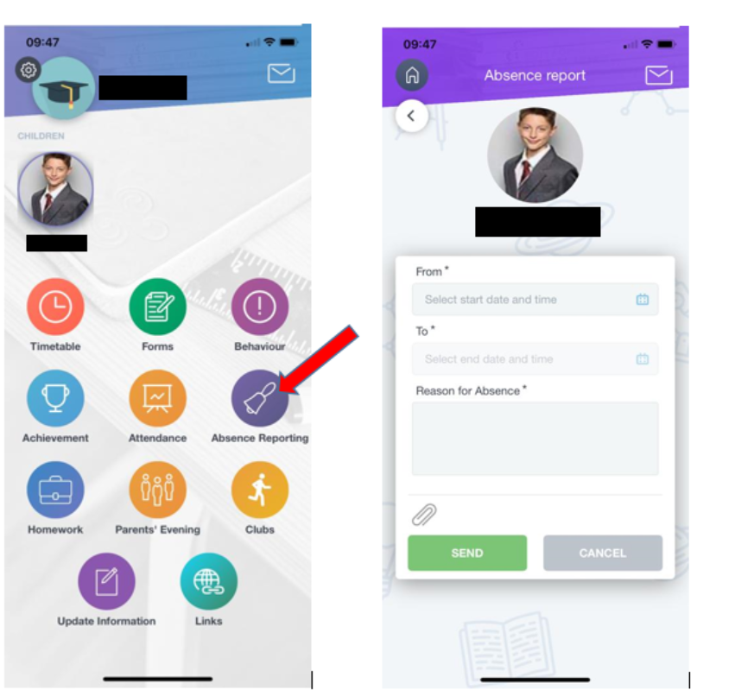

If you would like any support with this please contact Miss Pithers pithers@wellandparkacademy.com

If your child has no symptoms but tests positive using a LFD they will not need a subsequent PCR test (from the 11th January 2022)
The student should isolate and 2 successive negative test results from day 6 will enable them to return to school from day 7 if they do not have symptoms. This applies to tests no earlier than day 6 and the 2 successive negative tests should be 24 hours apart.
If the student has symptoms or continues to register a positive test, they must complete the 10 day isolation.

The UK Health Security Agency advises “Anyone who develops 1 of the 3 main COVID-19 symptoms should stay at home and self-isolate and take a PCR test. They must self-isolate if they get a positive test result, even if they have had a recent negative lateral flow test – these rules have not changed.”

The new guidance extends the recommendation for face coverings in school to be worn in the classroom in addition to communal areas. This guidance remains in place until 26th January 2022 when it will be reviewed by central government.
Thank you to the many parents who have ensured students have 2 clean, recyclable face coverings. We do have a supply of disposable masks at Student Services for 10p each if needed.

Students identified as a close contact of someone with COVID:19 should take a test daily for 7 days. If the result is negative, they should attend school as normal.

https://www.gov.uk/government/news/confirmatory-pcr-tests-to-be-temporarily-suspended-for-positive-lateral-flow-test-results

We continue to ensure good hygiene on site with an enhanced cleaning regime and well ventilated classrooms. Please reinforce regular hand sanitising with your child. We all enjoy some time outside as part of break/lunch or transitions between lessons. Additional thermal layers can be worn under uniform and woolly hats/gloves are becoming increasingly appreciated.

Parents of Year 9 students, we will reschedule the GCSE Options Evening to a point later in the term and I will write to confirm this date.

Thank you as always for your continued support, suggestions and feedback. The Governors and all staff work continuously to ensure our students can engage in learning with their specialist teachers on site. We are ready to switch to remote learning for students should this be appropriate. Please ensure your child has access to Teams so they are able to attend online lessons should the need arise. Any technical issues, please email helpdesk@wellandparkacademy.com

Yours sincerely

Julie McBrearty
Principal
Principal: Julie McBrearty BSc (Hons) MBA. Vice Principal: Matt Jerred BSc (Hons) MA
Assistant Principals: Cheryl Gerald, Danielle Pendell, Martin Towers (Associate), Caroline Bowden
A company limited by guarantee, registered in England and Wales, number 7675238. An exempt charity.
Registered Office: Welland Park Road, Market Harborough, Leicestershire LE16 9DR. Website: www.wellandparkacademy.co.uk

