

SPECIAL EDUCATIONAL NEEDS (SEN) & DISABILITY POLICY

|  |  |
| --- | --- |
| Reference this policy is aligned to with LCC | **n/a** |
| Agreed with Support Staff Trade Unions | **n/a** |
| Adopted by the Governing Body | **May 20** |
| Next Review Due | **Sep 22** |
| Agreed with Teacher Trade Unions and Professional Associations | **n/a** |

This policy complies with the statutory requirement laid out in the SEND Code of Practice 2015 and has been written with reference to the following guidance and documents:

* Equality Act 2010: Advice for schools DfE (Feb 2013)
* SEND Code of Practice 0-25 (Jan 2015)
* The children and families act 2014
* Schools SEN Information Report regulations (2016)
* Statutory Guidance on Supporting Students at school with medical conditions (Dec 2015)
* WPA Safeguarding Policy
* WPA Health and Safety Policy
* WPA Teaching and Learning Policy
* Teacher Standards 2012

It should be read in conjunction with the Welland Park Academy Special Educational Needs Report. This is available to parents on the school website and forms a contributory part of Leicestershire’s Local Authority’s Local Offer. More information about the Local Offer can be found on the Leicestershire County Council’s website.

This policy was created by the school’s SENDCO in liaison with the SEN Governor, SLT and all staff.

**SENDCO:** Sarah Kenning

**Position in School:** SENDCO

**Contact Details:** 01858 464795

[kennings@wellandparkacademy.com](mailto:kennings@wellandparkacademy.com)

### SEND Definition

In this policy, special educational needs and disabilities (SEND) refers to a child or young person who has a learning difficulty or disability, which calls for special educational provision to be made for them.

A child of compulsory school age or a young person has a learning difficulty or disability if they:

* have a significantly greater difficulty in learning than the majority of others the same age, or
* have a disability which prevents or hinders them from making use of facilities of a kind generally provided for others of the same age in mainstream schools or mainstream post-16 institutions

### Aims & Objectives of the Policy

**Our Aim** at Welland Park Academy is to raise the aspirations of, and expectations for, all students with SEND. Our school provides a focus on outcomes for children and young people to ensure they achieve their potential.

**Objectives:**

* To ensure opportunities are provided for every student to experience success through our ‘Learning for Life’ ethos.
* To promote individual confidence and a positive ‘can do’ attitude
* To accurately identify and provide for students with SEND
* To ensure all students, whatever their special educational need or disability, receive appropriate educational provision through a broad, balanced curriculum that is appropriately differentiated.
* To meet statutory requirements in the SEND Code of Practice, 2015
* To provide a Special Educational Needs Co-ordinator (SENDCO) who will work with the SEND Local Offer
* To provide support, information and advice to all staff regarding the students with SEND that they work with
* To ensure staff and governors are accountable for the SEND Policy being implemented and maintained
* Use the ‘assess, plan, do, review’ cycle to identify needs, plan interventions and monitor progress
* To ensure that the student has a ‘voice’ in their provision
* Involve parents/carers in planning and supporting at all stages of their child’s development

### Admission Arrangements

The processing of school admission applications is delegated to the Local Authority by Welland Park Academy. Allocation of places to the school is administered by the LA in Year 7. Neither a student’s abilities nor their learning difficulties feature in the admission of a student. We work closely with the LA when students apply for a placement with an Education Health Care Plan to determine whether we can meet the individual students needs in line with the EHCP. This consultation period might also involve parents, the youngsters themselves and relevant professinals.

### Identifying Special Educational Needs, Assessment Arrangements & Review Procedures

Quality first teaching, differentiated for individual students, is the first step in responding to students who have or may have SEND. Additional intervention and support cannot compensate for a lack of good quality teaching. In deciding whether to make special educational provision, the teacher and SENDCo will consider all of the information gathered from within the school about the student’s progress, alongside national data and expectations of progress.

Regular assessments of students’ progress will allow identification of students who are making less than expected progress given their age and individual circumstances. This can be characterised by progress which:

* is significantly slower than that of their peers starting from the same baseline
* fails to match or better the student’s previous rate of progress
* fails to close the attainment gap between the student and their peers
* widens the attainment gap

It is important to point out the circumstances which are **not** classed as SEND, but which may hinder progress and attainment:

* Disability
* Attendance and Punctuality
* Health and Welfare
* EAL
* Being in receipt of Pupil Premium (or Pupil Premium Plus) Grant
* Being a Looked After Child
* Being a child of a Serviceman/woman
* Having behavioural difficulties where an underlying cause has not been identified.

The Code of practice 2015 identifies 4 main areas of need:

* Cognition and Learning
* Communication and Interaction
* Sensory and/or Physical Needs
* Social, Emotional and Mental Health

The purpose of identification is to work out what action the school needs to take, not to fit a child into a category. At WPA, we identify the needs of students by considering the needs of the whole child and then matching the provision accordingly. A student may have needs in more than one area.

Where a student is identified as having an emerging SEND, action will be taken to address barriers to learning through a whole school approach, which includes quality first teaching together with support and guidance from the Learning Support and Pastoral teams. The student will be internally monitored, but not necessarily placed on the Inclusion Record. If the student continues to encounter barriers to their learning, a more targeted support programme may be put in place to help address more specific areas of need. The student may at this time be placed on the Inclusion Record at a status of ‘SEND Support’ (K). The SENDCO at this time may seek advice from external agencies for further strategies to support the student. This SEND support will continue through a four-part cycle where earlier decisions and actions are revisited, refined and revised with a growing understanding of the student’s needs and of what supports the student in making good progress and securing good outcomes. This support is funded through national schools SEND funding. Where, despite the school having taken relevant and purposeful action to identify, assess and meet the needs of the student, the student has not made expected progress, the school will consider requesting Higher Needs Funding and in very rare circumstances, an Education, Health and Care (EHC) needs assessment to access additional funding to support this student. The school, however, must demonstrate, from their own budget, that they have put the majority of the provision in place prior to an application for additional funding

To inform their decision about whether an EHC needs assessment is necessary the Local Authority will consider evidence that the student is not making progress, despite the provision put in place by the school. The school will provide:

* A SEND plan – this document will highlight a students’ SEND background, summary of needs and strengths, provision in place and recommended provision to improve outcomes

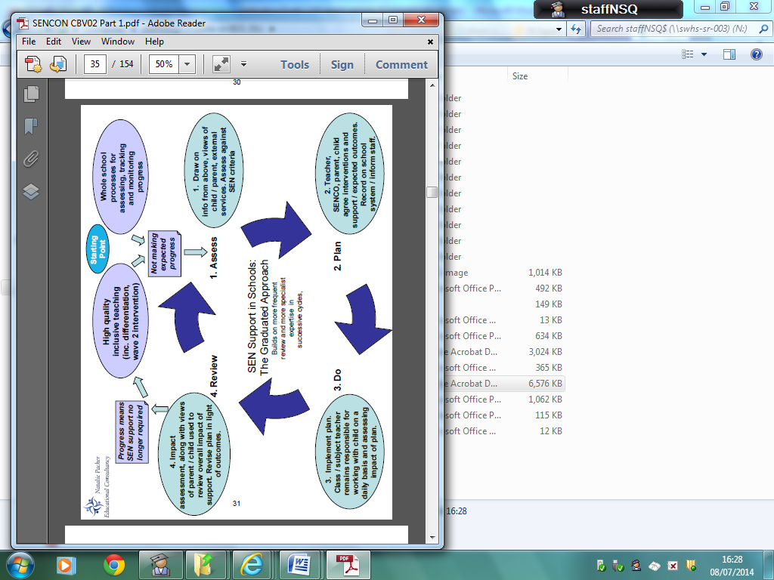

### Managing Students on the SEN Record

Each intake of students will be unique to that academic year and, as a result, provision will need to be personalised to meet the needs of individual students each year. The following outlines the procedures in place to monitor students on the SEN Record:

* All students on the Inclusion Record as an E (EHCP) or K (SEND support) will have a ‘pupil passport’ and ‘Provision Plan’, which is drawn up in conjunction with staff, parents and students. This details their specific special educational needs, their strengths, strategies that can be used to support them in the classroom and termly outcomes.
* Provision Plans are reviewed 3 times a year to ensure they are up to date and are then shared with students, parents and staff.
* Students who are on the Inclusion Record have their progress and attainment monitored regularly by the SENDCO in line with the school’s reporting system.
* Parents of students with SEND are invited during the year to discuss their child’s progress. This is timetabled to coincide with school parents’ evenings.
* The SEND Report and Provision Map for each year, documents the provision offered to students.
* If students make significant progress and no longer fit the criteria for SEND, then they exit the Inclusion Record formally but are subject to informal monitoring.

### Supporting Students & Families

* The Local Authority Local offer gives more detail on how parents can access support for their child. More information can be found here:

<https://www.leicestershire.gov.uk/education-and-children/special-educational-needs-and-disability/education-and-childcare>

* The school has a statutory requirement to provide a SEND Report, which can be found on the school’s website. This details other agencies that can support families and students and how we support students during times of transition from one phase of education to another etc.
* In order to support students at KS4, we screen all students to analyse their eligibility for Access Arrangements. This could be, and not limited to, a reader, extra time or scribe. Parents are kept fully informed of the results of this screening process. We run a robust data protection process with this and information is passed on to KS5 providers to support arrangements into KS5.
* We have a policy that determines how we manage students with medical conditions. This can be accessed by request to the main office.

### Supporting Students at school with Medical Conditions

The school recognises that students at school with medical conditions should be properly supported so that they have full access to education, including school trips and physical education. Some children with medical conditions may be disabled and where this is the case the school will comply with its duties under the Equality Act 2010.

Some may also have special educational needs (SEND) and may have an Education, Health and Care (EHC) plan which brings together health and social care needs, as well as their special educational provision and the SEND Code of Practice (2015) is followed.

If a student is diagnosed with a medical condition or disability, the school will organise a multi-disciplinary meeting to bring together all the professionals involved in the care of that student, plus their parents. The purpose of the meeting is to discuss the impact of that condition or disability upon their education and access to the curriculum at Welland Park. Actions will be generated from the meeting, such as a Health and Safety Audit, to ensure the smooth and safe transition of the student into the school wherever possible.

### Disability Access

The ground floor of our building is accessible via ramps and so is relatively wheelchair friendly, and we would seek to make as many reasonable adjustments as we were able with our current building structure and curriculum restrictions. We would work together with parents and outside agencies to provide a welcoming learning environment. We endeavour to make our site accessible for all. Where curriculum areas are restricted to certain areas of the school campus, we look to timetable and rooming alternatives to accommodate all our learners.

### Training & Resources

* The training needs of staff are identified through Performance Management and planned for through Departmental Improvement Plans, which are reviewed annually.
* In order to maintain and develop the quality of teaching and provision to respond to the strengths and needs of all students, all staff are encouraged to undertake training, development and regular CPD.
* All teachers and teaching support staff undertake induction on taking up a post and this includes a meeting with the SENDCO to explain the systems and structures in place around the school’s SEND provision and practice and to discuss the needs of individual students.
* The school’s SENDCO regularly attends the LA’s SENDCO network meetings in order to keep up to date with local and national updates in SEND.
* The SENDCO has NASEN membership to ensure she is regularly updated about SEND issues and to access training resources and consultancy input where needed.
* Local Area Special Schools are used to provide Outreach Work for the school where specialist training or knowledge is required.
* The SENDCOs in our local working group meet once a term to discuss various issues relating to the role.

### Roles & Responsibilities

At Welland Park Academy, provision for students with SEND, in the classroom, is the responsibility of subject teachers. Teachers are responsible and accountable for the progress and development of the students in their class, including where students access support from Teaching Assistants or specialist staff. All staff are responsible for following the school’s procedures for identifying, assessing and making provision to meet those needs.

**The Governing Body will ensure that:**

* SEND provision is an integral part of the school development plan
* necessary provision is made for any student with SEND
* staff are aware of the need to identify and provide for students with SEND
* students with SEND join in school activities alongside other students, as far as is reasonably practical and compatible with their needs and the efficient education of other students
* they have regard to the requirements of the SEND Code of Practice 2015
* they are fully informed about SEND issues, so that they can play a part in the school’s self-evaluation process
* they set up appropriate staffing and funding arrangements and oversee the school’s work for students with SEND
* the quality of SEND provision is regularly monitored
* a governor is identified to be the person responsible for SEND and for this person to link with Learning Support staff

**The Principal has responsibility for:**

* the management of all aspects of the school’s work, including provision for students with SEND
* keeping the governing body informed about SEND issues
* working closely with the SENDCO
* ensuring that the implementation of this policy and the impact on the school is reported to governors

**The Head of Learning Support (SENDCO) is responsible for:**

* overseeing of the day-to-day operation of the SEND policy
* overseeing the provision for students with SEND
* organising and managing the work of the Learning Support staff
* ensuring that an agreed, consistent approach is adopted
* liaising with and advising other staff
* helping staff to identify students with SEND
* carrying out detailed assessments and observations of students with specific learning problems
* supporting subject teachers in devising strategies, drawing up Pupil Passports and Provision Plans, setting targets appropriate to the needs of the students, advising on appropriate resources and materials for use with students with SEND and on the effective use of materials and additional adults in the classroom
* liaising closely with parents of students with SEND, so that they are aware of the strategies that are being used and are involved as partners in the process
* liaising with outside agencies, arranging meetings, and providing a link between these agencies, class teachers and parents
* maintaining the school’s SEND record and associated files
* assisting in the monitoring and evaluation process of students with SEND through the use of school assessment information
* contributing to in-service training of staff
* liaising with SENDCOs in other schools to help provide a smooth transition from one school to another
* developing good practice within a network of schools
* producing reports for the governors through the Principal’s annual report.
* ensuring the Welland Park Academy SEND Report is maintained and up-to-date

**Class teachers are responsible for:**

* teaching students with SEND in the classroom and for providing an appropriately differentiated curriculum
* making themselves aware of students SEND
* making themselves aware of the policy and the procedures for identification, monitoring and supporting students with SEND
* giving feedback to parents/carers of students with SEND

**Support staff (teaching assistants) should:**

* be fully aware of this policy and the procedures for identifying, assessing and making provision for students with SEND
* making themselves aware of the SEND of students they directly support
* assist in making provision for the individual needs of students identified as having SEND, whether in class, small groups or in Learning Support
* use the school’s procedures for giving feedback to teachers about students’ responses to tasks and strategies

### Storing & Monitoring Information

Confidential documents are stored in a lockable filing cabinet. Details about how long information if kept, when it is destroyed, passed on, stored etc can be found in the school’s Information Security Policy & Retention of Data Policy.

All data is and will be processed in line with the latest General Data Protection Regulations 2018.

Our SEND records are digitalised and kept securely on Provision Map online.

### Reviewing the Policy

Policy is kept under review by the SENDCO. This policy will be reviewed annually.Response to school closure and Covid-19

Following the Corona Covid-19 pandemic and associated unprecedented times, the school recognises that it is essential to continue and commit to providing our best endeavours for our students. At this time we continue to adhere to the Equality Act 2010 and the SEND Code of Practice 2015. With careful consideration of current government guidance we will continue to ensure we are meeting the needs of our students on the SEND register. During this time we will:-

* Ensure all students on the SEND register have fortnightly communication with a key adult from school
* Key workers will support students in accessing, completing, managing their workload and explore with the student alternative ways of accessing work
* Continue to work together with the youngster, family, professionals to uphold the best interests of the student
* Apply reasonable adjustments to remote learning where applicable
* Track and monitor the impact and outcomes of additional or altered provision
* Seek advice from multi-agency services when additional and urgent support is needed
* Provide staff with key information and training to help meet the student’s needs
* Uphold reasonable high expectations within the current evolving climate
* Continue provision under the assess, plan, do review cycle
* Review provision for SEND fortnightly

In addition for students with an EHCP, we will also:-

* Facilitate a weekly communication session with the student unless agreed otherwise with parents
* Continue to perform annual reviews remotely with parental consent
* Offer provision where possible as stated in their EHCP documents
* Complete fortnightly ‘Student EHCP Risk Assessment’ in conjunction with the LA